Machine Learning (ML)
06 – 05 - 2026

1. Artificial Intelligence vs Machine Learning
Topic | Description
Artificial Intelligence (AI) | Mimics human capabilities such as thinking, decision-making, prediction, creativity, reasoning, and problem-solving.
Machine Learning (ML) | A subset of AI where systems learn patterns from data and make predictions or decisions automatically.

2. Relationship Between AI and ML
Artificial Intelligence (AI)
↓
Machine Learning (ML)
- AI → Broad field focused on intelligent systems.
- ML → Subfield of AI focused on learning from data.

3. Traditional Programming vs Machine Learning
Traditional Programming
Input + Logic → Output
Example
Marks + Formula → Grade
The programmer manually writes all rules and logic.

Machine Learning Programming
Input + Output → Machine Learns Logic
Example: House Price Prediction
Inputs (Features)
- 3 Bedrooms
- Kitchen
- Hall
- Attached Bathrooms
- Dining Room
- Car Porch
- Pool
- Home Theatre
- Balcony
- Garden
- Store Room
- Stair
- Sitout
Output (Label)
House Price = 75 Lakhs
The ML algorithm learns the relationship between house features and price automatically.

4. Machine Learning Workflow (ML Lifecycle)
Step | Description
1. Data Collection | Gather data from sources such as YouTube, websites, databases, textbooks, sensors, etc.
2. Data Preprocessing & Visualization (EDA) | Clean and analyze data before training.
3. Model Selection & Training | Choose suitable ML algorithm and train the model.
4. Model Evaluation & Testing | Measure model performance using test data.
5. Deployment | Deploy the trained model into real-world applications.

5. Data Preprocessing & EDA (Exploratory Data Analysis)
Around 50% of ML work is spent in EDA and preprocessing.
Common Preprocessing Tasks
MODE FD
Task | Purpose
Missing Value Handling | Fill or remove missing data
Duplicate Removal | Remove repeated records
Encoding | Convert categorical data into numerical format
Feature Scaling | Normalize or standardize values
Outlier Detection | Identify abnormal data points
Data Visualization | Understand trends and relationships

6. Types of Machine Learning

A. Supervised Learning
Definition
Supervised learning uses labeled data.
- Input data is provided along with the correct output.
- The model learns from these examples.
Structure
Input Data + Correct Output(Label) → Model Training

Example
Email Text | Label
"Win a free iPhone now!" | Spam
"Meeting at 5 PM" | Not Spam
The model learns how to classify emails.

Types of Supervised Learning
1. Classification
- Output is a categorical value.
Examples
- Spam vs Non-Spam Emails
- Disease Detection
- Fraud Detection
Common Algorithms
Algorithm
SKLDRN → resembles “sklearn” (ML-related)
K-Nearest Neighbors (KNN)
Naive Bayes
Decision Tree
Random Forest
Support Vector Machine (SVM)
Logistic Regression

2. Regression
- Output is a continuous numerical value.
Examples
- House Price Prediction
- Stock Price Prediction
- Temperature Prediction
Common Algorithms
Algorithm
Linear Regression
Polynomial Regression

B. Unsupervised Learning
Definition
Unsupervised learning uses unlabeled data.
- No correct output is provided.
- The model tries to find hidden patterns or structures.
Examples
- Customer Segmentation
- Pattern Detection
- Recommendation Systems
Common Tasks
Task | Example
Clustering | Group similar customers
Association | Market basket analysis
Dimensionality Reduction | Reduce feature count

C. Reinforcement Learning
Definition
An agent learns by interacting with the environment using:
- Rewards
- Punishments
Structure
Action → Reward/Penalty → Learning
Examples
- Self-driving cars
- Robotics
- Game-playing AI
- Recommendation optimization

7. Important Machine Learning Algorithms
Algorithm | Type | Use Case
KNN | Classification | Similarity-based prediction
Naive Bayes | Classification | Text classification
Decision Tree | Classification/Regression | Rule-based prediction
Random Forest | Classification/Regression | Ensemble learning
SVM | Classification | Margin-based classification
Logistic Regression | Classification | Binary classification
Linear Regression | Regression | Predict continuous values
Polynomial Regression | Regression | Non-linear relationships

8. Key Points to Remember
Concept | Note
AI | Mimics human intelligence
ML | Learns from data
Supervised Learning | Uses labeled data
Unsupervised Learning | Uses unlabeled data
Regression | Predicts numbers
Classification | Predicts categories
EDA | Critical preprocessing phase
Deployment | Final production stage

9. Simple ML Flow Diagram
Data Collection
↓
Data Preprocessing & EDA
↓
Model Selection
↓
Model Training
↓
Model Evaluation
↓
Deployment

10. Real-World Applications of ML
Domain | Example
Healthcare | Disease prediction
Finance | Fraud detection
E-commerce | Product recommendation
Real Estate | House price prediction
Banking | Credit scoring
Social Media | Feed recommendation
Cybersecurity | Spam and threat detection

07 – 05 - 2026
Training and Testing Overview
Machine learning models are typically evaluated by splitting the dataset into training and testing portions.
Common Data Split Ratios
Split Type | Training Data | Testing Data | Notes
Standard Split | 80% | 20% | Commonly used for model development
Holdout Split | 70% | 30% | Another widely used evaluation approach
Dataset Structure
A dataset usually contains:
- Features: Input variables used to make predictions.
- Target / Label: Output variable the model is trained to predict.
Target Types
Target Type | Description
Binary Classification | Two classes, such as 0 and 1
Multi-class Classification | More than two classes, such as 3-class or 10-class problems
Example: Iris Dataset
The Iris dataset is a classic example of a multi-class classification problem.
Classes in the Iris Dataset
Class Number | Species
1 | Setosa
2 | Versicolor
3 | Virginica
Classification
Classification is used when the target variable is categorical.
- Binary classification predicts one of two classes.
- Multi-class classification predicts one among three or more classes.
K-Nearest Neighbors (KNN)
KNN stands for K-Nearest Neighbors.
Key Characteristics
- It is a supervised learning algorithm.
- It is a distance-based learning method.
- It classifies a data point based on the classes of its nearest neighbors.
Distance Measures in KNN
KNN relies on distance metrics to identify the nearest data points.
Common Distance Metrics
- Euclidean Distance
- Manhattan Distance
Example Points
- $P_{1}=(x_{1},y_{1})$
- $P_{2}=(x_{2},y_{2})$
These points are used to calculate the distance between observations for classification purposes.
- Euclidean Distance
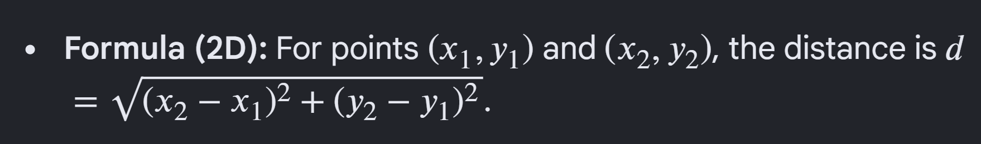
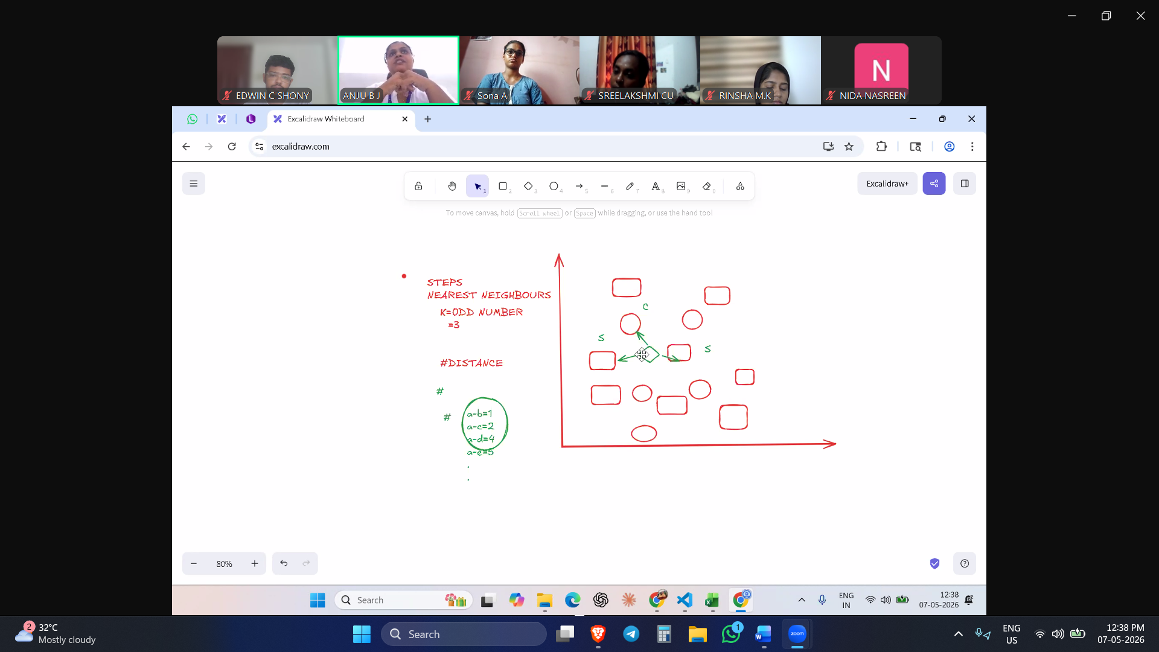

Categorical -- voting
points | x | y | target
p1 | 7 | 4 | bad
p2 | 7 | 8 | bad
p3 | 4 | 3 | good
p4 | 4 | 2 | good

See notebook also
Machine Learning Question and Answer Bank (50 Questions)
Basic Level
1. What is Artificial Intelligence (AI)?
Answer: Artificial Intelligence (AI) is a technology that enables machines to mimic human intelligence such as thinking, reasoning, decision-making, learning, and problem-solving.

2. What is Machine Learning (ML)?
Answer: Machine Learning (ML) is a subset of AI where systems learn patterns from data and make predictions or decisions automatically.

3. Explain the relationship between AI and ML.
Answer: AI is the broader field focused on creating intelligent systems, while ML is a subfield of AI that enables systems to learn from data.

4. What is the difference between traditional programming and machine learning?
Answer: In traditional programming, the programmer writes rules manually. In machine learning, the system learns the rules automatically from data.

5. What are features in a dataset?
Answer: Features are the input variables or attributes used by a machine learning model to make predictions.

6. What is a target (label) in machine learning?
Answer: A target or label is the output variable that the model is trained to predict.

7. Define supervised learning.
Answer: Supervised learning is a type of ML where the model is trained using labeled data containing both inputs and correct outputs.

8. Define unsupervised learning.
Answer: Unsupervised learning is a type of ML where the model learns patterns from unlabeled data without correct outputs.

9. Define reinforcement learning.
Answer: Reinforcement learning is a learning method where an agent learns by interacting with the environment using rewards and punishments.

10. What is classification in machine learning?
Answer: Classification is a supervised learning task where the output is a categorical value such as spam/not spam.

11. What is regression in machine learning?
Answer: Regression is a supervised learning task used to predict continuous numerical values.

12. Give two examples of classification problems.
Answer: Spam email detection and disease prediction are examples of classification problems.

13. Give two examples of regression problems.
Answer: House price prediction and temperature prediction are examples of regression problems.

14. What is Exploratory Data Analysis (EDA)?
Answer: EDA is the process of analyzing and visualizing data to understand patterns, trends, and relationships before model training.

15. Why is data preprocessing important in ML?
Answer: Data preprocessing improves data quality by handling missing values, duplicates, and inconsistencies, leading to better model performance.

16. What are missing values in a dataset?
Answer: Missing values are data entries where some information is absent or not recorded.

17. Name any four real-world applications of machine learning.
Answer: Healthcare, finance, e-commerce, and cybersecurity are common real-world applications of ML.

Intermediate Level
18. Explain the ML lifecycle with steps.
Answer: The ML lifecycle includes Data Collection, Data Preprocessing & EDA, Model Selection, Model Training, Model Evaluation, and Deployment.

19. What is the purpose of data preprocessing?
Answer: Data preprocessing cleans and transforms raw data into a suitable format for machine learning.

20. What is encoding in machine learning?
Answer: Encoding converts categorical data into numerical form so that ML algorithms can process it.

21. What is feature scaling?
Answer: Feature scaling normalizes or standardizes feature values to improve model performance.

22. What are outliers in a dataset?
Answer: Outliers are abnormal or extreme data points that differ significantly from other observations.

23. Explain duplicate removal in preprocessing.
Answer: Duplicate removal eliminates repeated records from the dataset to improve data quality.

24. Differentiate between binary classification and multi-class classification.
Answer: Binary classification has two classes, while multi-class classification has more than two classes.

25. Explain the Iris dataset and its classes.
Answer: The Iris dataset is a famous ML dataset containing three flower classes: Setosa, Versicolor, and Virginica.

26. What is K-Nearest Neighbors (KNN)?
Answer: KNN is a supervised learning algorithm that classifies data based on the nearest neighboring data points.

27. Why is KNN called a distance-based algorithm?
Answer: KNN uses distance metrics to identify the nearest neighbors for prediction.

28. What is Euclidean distance in KNN?
Answer: Euclidean distance measures the straight-line distance between two points.
genui{"math_block_widget_always_prefetch_v2":{"content":"d=\sqrt{(x_2-x_1)^2+(y_2-y_1)^2}"}}

29. What is Manhattan distance in KNN?
Answer: Manhattan distance measures the distance between two points by summing the absolute differences of coordinates.
d=|x_2-x_1|+|y_2-y_1|

30. Explain how KNN performs classification using voting.
Answer: KNN identifies the nearest neighbors and assigns the class that appears most frequently among them.

31. What are the common train-test split ratios used in ML?
Answer: Common train-test split ratios are 80:20 and 70:30.

32. Why is testing data necessary in machine learning?
Answer: Testing data evaluates how well the trained model performs on unseen data.

33. Differentiate between labeled and unlabeled data.
Answer: Labeled data contains input-output pairs, while unlabeled data contains only inputs without outputs.

34. Compare supervised learning and unsupervised learning.
Answer: Supervised learning uses labeled data, whereas unsupervised learning uses unlabeled data to find hidden patterns.

Advanced Level
35. Explain how machine learning learns logic automatically from data.
Answer: ML algorithms analyze patterns and relationships in training data and automatically generate prediction rules without explicit programming.

36. Describe the workflow of house price prediction using ML.
Answer: The workflow includes collecting house feature data, preprocessing it, training a regression model, evaluating performance, and predicting house prices.

37. Why does EDA consume a major portion of ML work?
Answer: EDA is time-consuming because data must be cleaned, visualized, and analyzed before model training.

38. Explain clustering with a real-world example.
Answer: Clustering groups similar data points together. Example: customer segmentation in e-commerce.

39. What is dimensionality reduction? Why is it useful?
Answer: Dimensionality reduction decreases the number of features to simplify models and improve efficiency.

40. Explain association learning with an example.
Answer: Association learning identifies relationships between items. Example: customers buying bread also buy butter.

41. How does reinforcement learning use rewards and punishments?
Answer: Reinforcement learning improves decisions by rewarding correct actions and penalizing incorrect actions.

42. Explain the role of an agent in reinforcement learning.
Answer: The agent interacts with the environment, takes actions, and learns from rewards or penalties.

43. Compare classification and regression with suitable examples.
Answer: Classification predicts categories such as spam/not spam, while regression predicts numerical values such as house prices.

44. Explain how KNN classifies a new data point using nearest neighbors.
Answer: KNN calculates distances between the new point and existing points, selects the nearest neighbors, and predicts the majority class.

45. What happens if the value of K in KNN is too small or too large?
Answer: A very small K may cause overfitting, while a very large K may reduce accuracy due to excessive smoothing.

46. Differentiate between Euclidean distance and Manhattan distance.
Answer: Euclidean distance measures straight-line distance, whereas Manhattan distance measures path distance along axes.

47. Explain ensemble learning in Random Forest.
Answer: Random Forest combines multiple decision trees to improve prediction accuracy and reduce overfitting.

48. Why is Logistic Regression used for binary classification?
Answer: Logistic Regression predicts probabilities between 0 and 1, making it suitable for two-class classification problems.

49. Compare Decision Tree and Random Forest algorithms.
Answer: Decision Tree uses a single tree for prediction, while Random Forest combines multiple trees for better accuracy and stability.

50. Explain the importance of deployment in the ML lifecycle.
Answer: Deployment makes the trained ML model available for real-world use in applications and systems.

08 – 05 - 2026

